Raspberry Pi Project

1 installing Motioneyeos
  - Formatting microSd card
  - Downloading the OS image
  - Writing the image
  - Booting MotionEye on Raspberry Pi
  - Finding your Raspberry Pi IP address
  - Accessing MotionEye for the first time

- Configuration Motioneyeos

  - Initial setup
  - Normal use
  - Initial setup screenschots
3 Remote access Raspberry Pi
3.1 Enable ssh
1. Enable ssh from desktop menu
2. Enable ssh from terminal
3. Enable ssh with systemctl
4. Enable ssh on a headless Raspberry pi
3.2 ssh into Raspberry pi
1. ssh into Raspberry pi with terminal
2. ssh into Raspberry pi with putty
4 Remote access motioneyos
4.1 remote access live feed from Raspberry pi
4.2 cloud storage video and images
4.3 notification for motion detection
5 Python script
  - Monitoring Raspberry pi Gpio with motioneyeos
    - What are monitoring command?
    - Enabling a monitoring command
    - Execution rate
    - Create and execute script

Raspberry Pi Project

Summary home surveillance system with raspberry pi
Requirements:
ssh access
remote access
python script

Hardware:
1 x Raspberry Pi 3 Model B+
1 x micro sd card
1 x Raspberry Pi cam
1 x ethernet cable
1 x power supply

Installing MotionEyeOS

1.1 Formatting microSD card
- Go to https://www.sdcard.org/downloads/formatter_4/ and download the SD Card Formatter software for your operating system.
- Install the SD Card Formatter software.
- With your microSD card connected to your computer, open the SD card Formatter application, and format your microSD card with the “overwrite format” option.

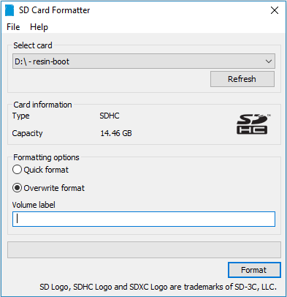

1.2 Downloading the OS Image
MotionEyeOS releases page.
For Raspberry Pi 3 download https://github.com/ccrisan/motioneyeos/releases/download/20190911/motioneyeos-raspberrypi3-20190911.img.xz

1.3 Writing the Image

Next, extract the image from the .zip folder. Then, you can use win32diskimager or Etcher, to write the image onto the SD card.
With the microSD card formatted, and connected to your computer, open Etcher. Select the image you’ve get previously, select your microSD card, and click Flash!
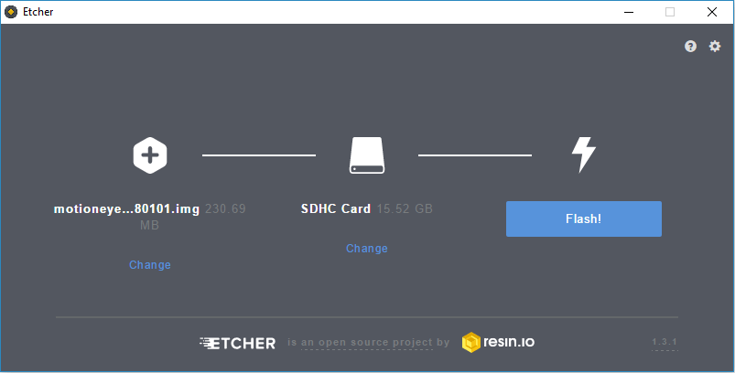
When the flash is completed, your microSD card is ready!
1.4 Booting MotionEyeos on Raspberry Pi
1. Insert the microSD card in the Raspberry Pi;
2. Connect an Ethernet cable – this is needed on the first boot;
3. Connect a camera. If you’re using the Raspberry Pi camera V2 module, make sure you’ve connected the camera in the right orientation as shown in the following image
4. Apply power to your Pi and wait for about 2 minutes for the system to be ready.

1.5 Finding Your Raspberry Pi IP Address
To Find your Raspberry Pi IP address, you can use Advanced Ip Scanner. The IP you’re looking for is the one with “meye” on the name, as shown in the following figure.
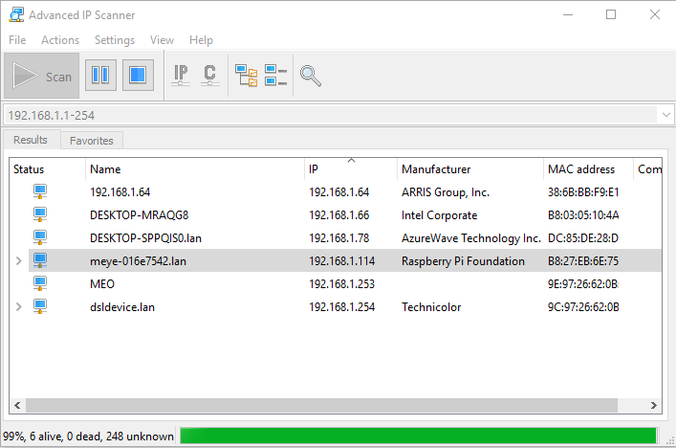

1.6 Accessing MotionEye For the First Time
Open your browser and type the Raspberry Pi IP address. You’ll see the MotionEye
login page.
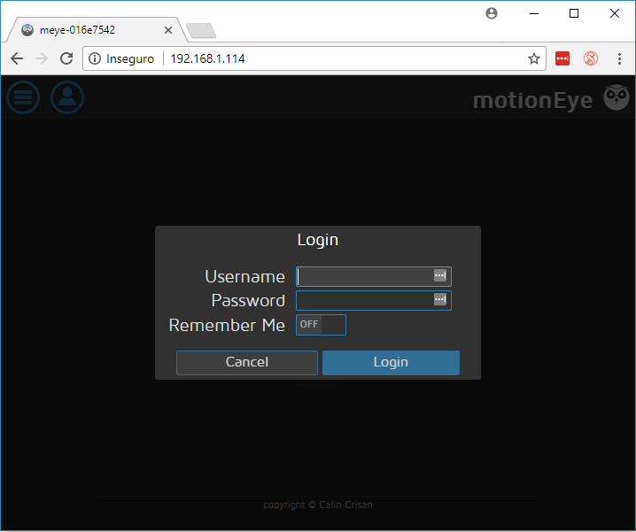
At the first boot, use the following credentials:
- Username: admin
- Password: [No password, leave blank]
If you have a camera connected to your Pi, it should be detected automatically, and you should see a live image from the camera. We’ve connected two cameras, an USB camera, and the Raspberry Pi Camera V2 module, and it automatically shows live image from both.
- Configuration Motioneyeos

2.1 Initial Setup
The web user interface allows you to configure pretty much everything. You'll probably want to enable the advanced settings option. Here are the most important things you should take care of when configuring your motionEyeOS for the first time:
- set a password for the two users (admin and user)
- set the correct timezone for your region
- enable the wireless connection, if you have one
- configure your video device(s) (resolution, framerate etc)
- configure the file storage if you want your pictures/movies saved on a network or USB drive
- enable still images and/or motion movies if you want any information to be recorded
The installed camera devices are normally automatically detected and configured for you, but you can however add more devices (including remote devices) from the settings panel.

2.2 Normal Use
There are two users that can be used to access the web interface: admin and user. The former is meant for administrative purposes while the later should be used for surveillance.
Most modern browsers, including the mobile ones, should work fine with the web interface. Just point your browser to the IP address of your motionEyeOS (on port 80) and enter your credentials. The cameras will automatically refresh according to their configured streaming refresh rate. You can click on any of them to display it alone or you can use the full screen button of each camera to open a full window/tab displaying only that camera.
Movies and pictures taken by each camera can be browsed, previewed and downloaded using the media browser window which opens by clicking on the pictures or movies buttons.
These pictures and movies recored by motionEyeOS are visible on the local network as well. Just look for your motionEyeOS system in your network in a Windows Explorer window or use the smb://your_motion_eye/ URL if on Linux. The two shares, sdcard and storage represent the local SD card data partition and any other attached storage, respectively.
You can access your files using an FTP as well, unless you have tweaked your system otherwise. Your motionEyeOS can be browsed using virtually any FTP client.
  - Initial setup screenshots

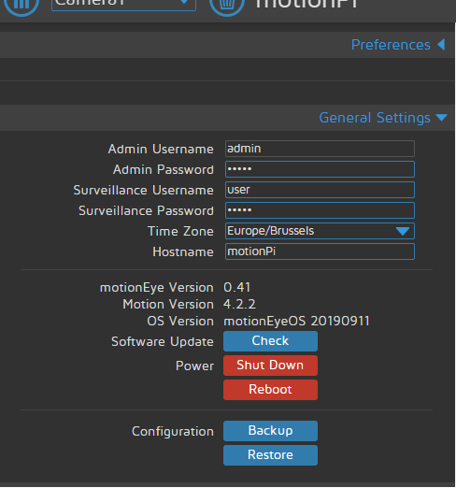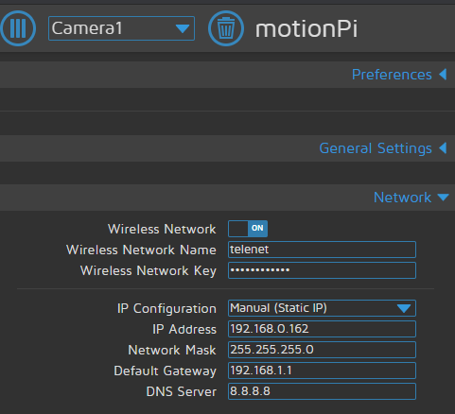
General settings Network
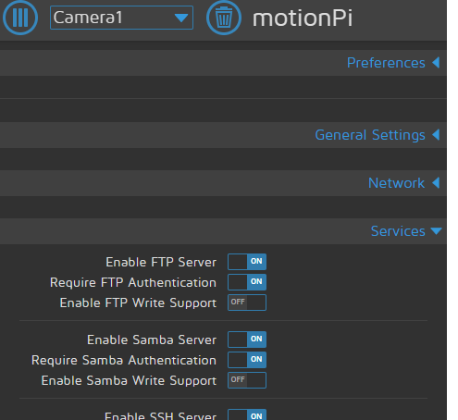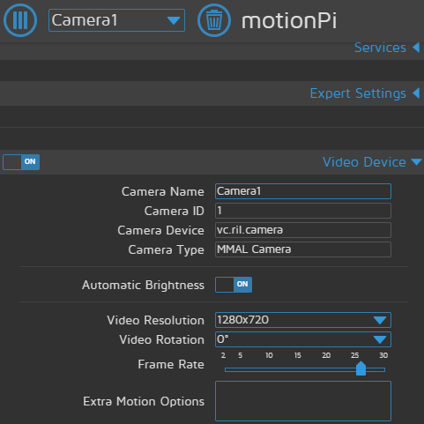
Services Video Device

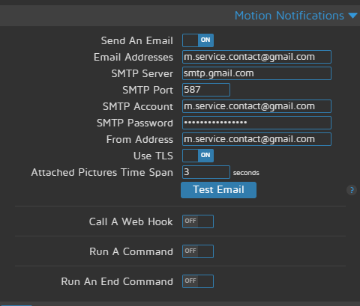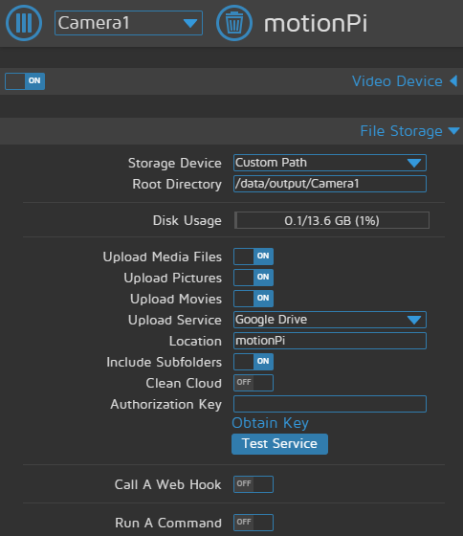
Motion Notification File Storage

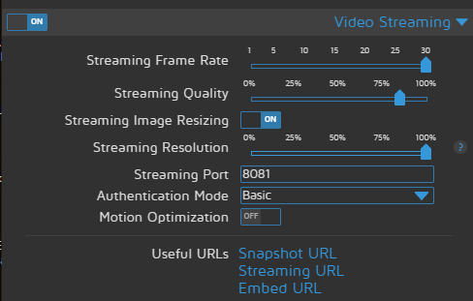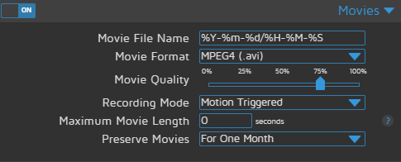
Video Streaming Movies
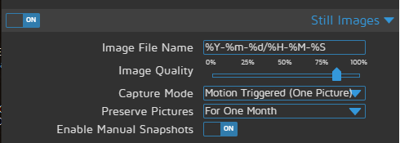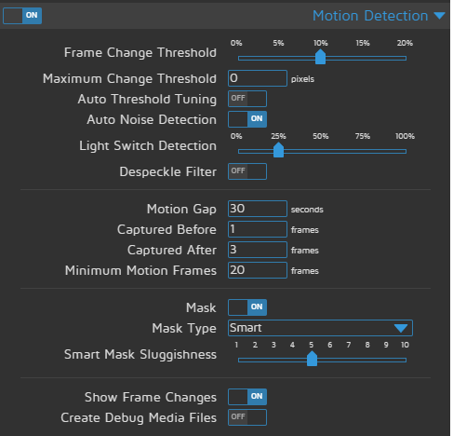
Still images Motion Detection

- Remote access Raspberry Pi

3.1 Enable ssh
As of the November 2016 release, Raspian has the ssh server disabled by default.
It can be enabled manually

      - enable ssh from dektop menu

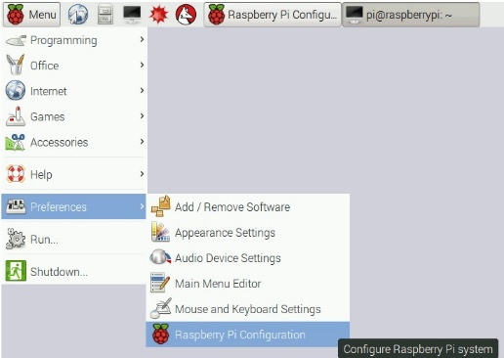
1.Launch Raspberry pi configuration from the preferences menu
2.Navigate to the interfaces tab
3.Select Enabled next to ssh
4.click ok
3.1.2 enable ssh from terminal
raspi-config can be used in the terminal
1.Enter sudo raspi-config
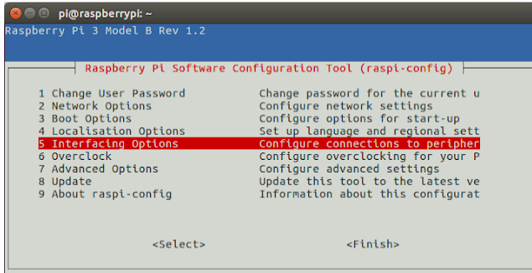
2.select Interfacing options
3.navigate to and select ssh
4.choose yes
5.select ok
6.choose finish

3.1.3 enable ssh with systemctl in the terminal
use systemctl to start the service
sudo systemctl enable ssh
sudo systemctl start ssh
3.1.4 enable ssh on a headless Raspbery Pi (add file to sd card on another machine)
For headless setup, ssh can be enabled by placing a file named ssh, without Any extension, onto the boot partition of the sd card from another computer. When the Pi boots it looks for the ssh file. If it is found, ssh is enabled and the file is deleted. The content of the file does not matter; it could contain text or nothing at all. If you have loaded Raspian onto a blank sd card you will have two partitions. The first one , which is the smallest one, is the boot partition. Place the file into this one.

3.2 ssh into Raspberry pi
1. ssh into Raspberry pi with terminal
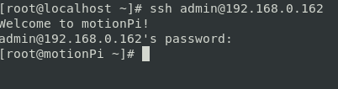
2.ssh into Raspberry pi with putty

    - Download putty from https://www.chiark.greenend.org.uk/~sgtatham/putty/
    - Enter ip address and port nr 22

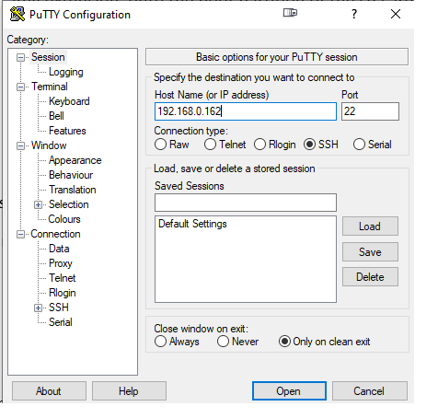
. enter username
. enter password
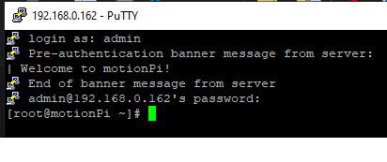

- Remote access motioneyos

  - remote access live feed from Raspberry pi camera
1 motioneyeos configuration

2 portforwarding router

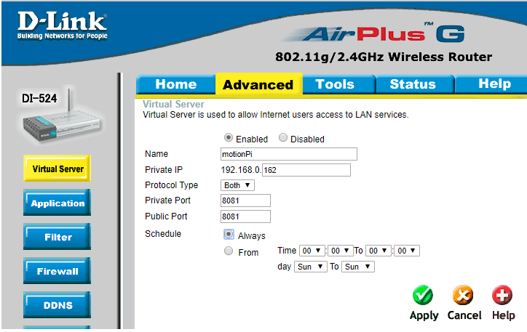

  - cloud storage video and images

1 motioneyeos configuration

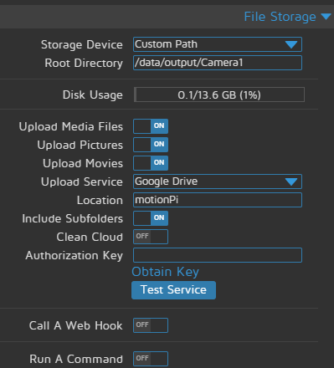

- setup GoogleDrive

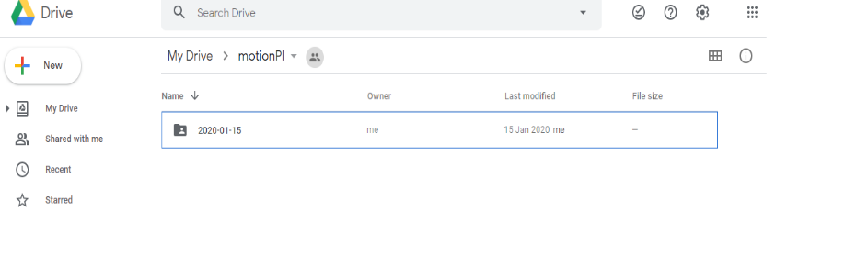

4.3 Notification for motion detection
1 motioneyeos configuration
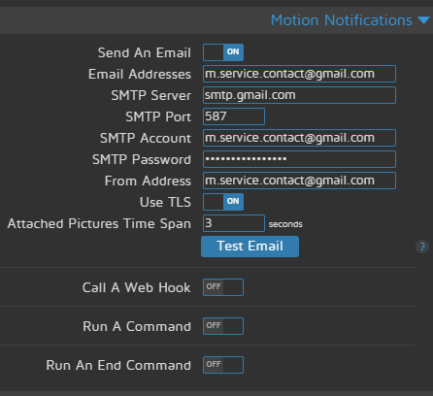

2 screenschot mail account
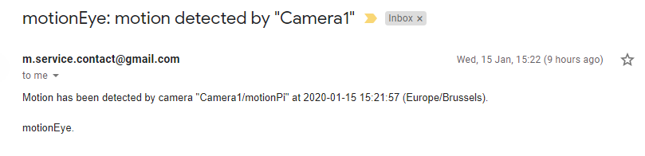
- Python script

  - Monitoring Raspberry pi Gpio with motioneyeos

      - What are monitoring command?

Starting with version 0.32, motionEye can be configured to overlay monitoring information on top of a camera frame. The information is gathered by running a command and capturing its output. These commands can be configured on a per-camera basis and are usually shell scripts provided by the user. Monitoring commands can be used to watch system parameters such as the system load, the CPU temperature or the network transfer rate.

      - Enabling a monitoring command

motionEye will look inside its configuration folder for executable files named monitor_[cameraid], where cameraid is the id of the camera on top of which the monitoring info will be displayed.
For example, on a setup using the default configuration, the presence of the executable file /data/etc/monitor_1 will determine motionEye to run the script every 1 second (by default), to read its standard output and to display it on top of the first camera frame.

      - Execution Rate

By default, all monitoring scripts are called every 1 second. If a script wishes to explicitly reschedule its next execution, it should simply write the delay, in seconds, to its standard error.

    - Create and execute script

. Navigate to the etc directory: cd /data/etc
. Create file named “monitor_1” : nano monitor_1
. Script:
#!/bin/bash

GPIOA=17
GPIOA_title="Door 1 "
GPIOB=27
GPIOB_title="Door 2"

test -e /sys/class/gpio/gpio$GPIOA || (echo $GPIOA > /sys/class/gpio/export && echo in > /sys/class/gpio/gpio$GPIOA/direction)
test -e /sys/class/gpio/gpio$GPIOB || (echo $GPIOB > /sys/class/gpio/export && echo in > /sys/class/gpio/gpio$GPIOB/direction)
valA=$(cat /sys/class/gpio/gpio$GPIOA/value)
valB=$(cat /sys/class/gpio/gpio$GPIOB/value)

if [ "$valA" == "1" ]; then
GPIOA_text="CLOSED"
else
GPIOA_text="OPEN"
fi

if [ "$valB" == "1" ]; then
GPIOB_text="CLOSED"
else
GPIOB_text="OPEN"
fi
echo "$GPIOA_title:$GPIOA_text - $GPIOB_title:$GPIOB_text"
echo 1 1>&2

the above script is to display the status of two doors closed or open. The magnetic switches are mounted on the doors.
the switches are connected to the GPIO pin 3.3v. When the door is opened the connection is broken and the GPIO pin is pulled low by the pi’s pull-down resistors

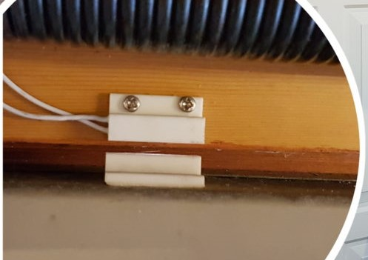

. make script executable
Chmod +x monitor_1
. test script
Sh ./monitor_1
. Reload web-interface
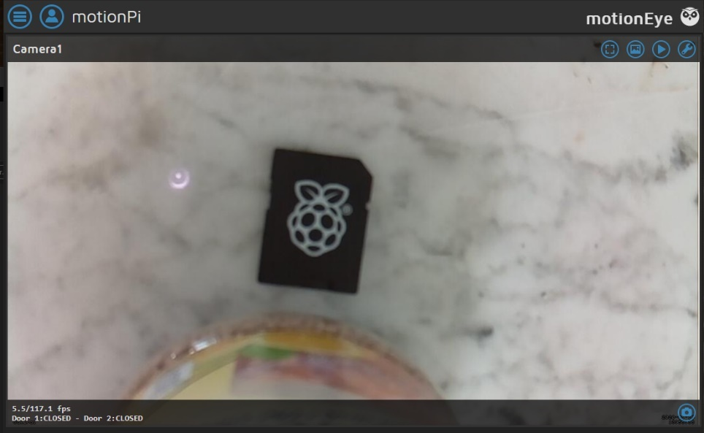
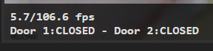

Product Raspberry Pi 3 Model B+ Product information
Product number
- 810799
- 836200
Manufacturer code
- 2848199
- RPI4-MODBP-4GB
Brand
- Raspberry Pi
- Raspberry Pi
Warranty
- 2 years
- 2 years
Warranty type
- Carry-in warranty
- Carry-in warranty

Processor
Processor brand
- Broadcom
- Broadcom
Processor code name
- Model B+
- Cortex
Processor cores
- Quad-Core (4)
- Quad-Core (4)
Clock speed
- 1,4 GHz
- 1,5 GHz
- Product Raspberry Pi 3 Model B+ Product information

Turbo speed
- 1,4 GHz
- 1,5 GHz
Cache memory
- 512 KB
- 512 KB

RAM
Internal RAM present
- Yes
- Yes
Internal RAM
- 1 GB
- 4 GB
Expandable memory
- No
- No
Number of memory channels
- Single channel (1)
- Single channel (1)
Memory type
- DDR2

Video card
Type of video card
- None
- None

Storage
Memory card included

Product Raspberry Pi 3 Model B+ Product information
No
- No

Wireless connections
Bluetooth
- Yes
- Yes
Bluetooth version
- 4.2
- 5.0
NFC
- No

Integrated WiFi
- Yes
- Yes
WiFi standards
- Wireless AC, Wireless G, Wireless N
- Wireless AC, Wireless G, Wireless N

Wired connections
Headphone jack
- Yes
- Yes
Type of headphone connection
- 3.5mm mini jack
- 3.5mm mini jack
Number of headphone jacks
- 1
- 1
WiFi standards
- Wireless AC, Wireless G, Wireless N
- Wireless AC, Wireless G, Wireless N
- Product Raspberry Pi 3 Model B+ Product information
NFC
- No

Bluetooth
- Yes
- Yes
Integrated WiFi
- Yes
- Yes
Bluetooth version
- 4.2
- 5.0
Number of female 3.5mm TRS Audio Jack ports
- 1
- 1
Version female micro USB-B (2.0 form factor) port
- 2.0
- 2.0
Number of female micro USB-B (2.0 form factor) ports
- 1
- 1
Female standard USB-A port version
- 3.0
- 3.0
Number of female standard USB-A ports
- 4
- 2
Number of HDMI ports
- 1
- 2
Female HDMI Type A port version
- 1.4

Number of Female HDMI type A 1.4 ports
- 1

Product Raspberry Pi 3 Model B+ Product information

Microphone connection
- No
- No
Number of ethernet ports
- 1
- 1
Ethernet speed
- Gigabit Ethernet (1000Mbps)
- Gigabit Ethernet (1000Mbps)
Female HDMI Type D port version

- 1.4
Number of Female HDMI type D 1.4 ports

- 2

Power source
Minimum required PSU (power supply unit)
- 12,5 W
- 12,5 W
Voltage
- 5 V
- 5 V

Physical properties
Weight
- 0,5 kg
- 0,5 kg
Width
- 85 mm
- 85 mm
Depth

- Product Raspberry Pi 3 Model B+ Product information
- 17 mm
- 17 mm
Height
- 56 mm
- 56 mm

Steps
- Format sd card
- Install Raspbian-buster-full

Raspberry Pi Camera Product information

Technical Details
Collapse all
Summary
Screen Size | 1
Max Screen Resolution | Raspberry Pi Camera pixels
Processor | 1 GHz 8031
RAM | 1 GB Raspberry Pi Camera
Hard Drive | 1 GB Raspberry Pi Camera
Card Description | Raspberry Pi Camera
Graphics Card Ram Size | 1 GB
Number of USB 2.0 Ports | 1
Number of USB 3.0 Ports | 1
Other Technical Details
Brand Name | kuman
Series | Raspberry Pi Camera
Item model number | SC15-US-NFBA
Operating System | Raspberry Pi Camera
Item Weight | 1.6 ounces
Package Dimensions | 4.4 x 3 x 1.3 inches
Color | black
Processor Brand | Raspberry Pi Camera
Hard Drive Interface | USB 2.0/3.0
Hard Drive Rotational Speed | 1 RPM
Optical Drive Type | Raspberry Pi Camera

Technical Specification
User Manual [pdf ]

